EE3320 Test 1 2011-2012 Semester B

Question 1. (20 marks)

Suppose within your web browser you click on a link to obtain a web page. Suppose that web page associated with the link contains a small amount of HTML text. Let RTT denote the round trip time between the local host and the server containing the HTML file. Further suppose the page references fourteen objects each with size L and the transmission rate R. Assuming zero queueing time of the objects, how much time is needed from when the client clicks on the link until the client receives all the fourteen referenced objects with
i) non-persistent HTTP with parallel TCP connections but the maximum number of parallel connections is set to two? [4 marks]
ii) non-persistent HTTP with parallel TCP connections but the maximum number of parallel connections is set to four? [4 marks]
iii) non-persistent HTTP with no parallel connections? [4 marks]
vi) persistent HTTP with pipelining? [4 marks]
v) persistent HTTP without pipelining? [4 marks]

i) 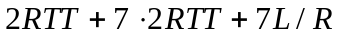 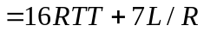.
ii) 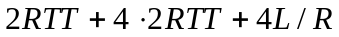 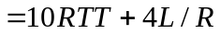.
iii)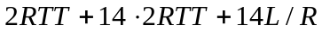 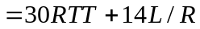.
iv) 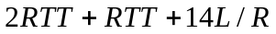 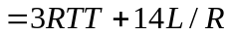.
v) 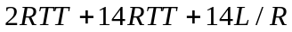 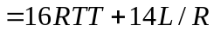.

Question 2. (30 marks)

Consider Figure Q. 2, in which there is an institutional network connected to the Internet. Suppose that the average object size is 900,000 bits and that the average request rate from the institution’s browsers to the origin servers is 5400 requests per hour. Also suppose that the amount of time it takes for the signal traveling from the router on the Internet side of the access link to the origin servers is three seconds on average. Assume that it takes the same amount of time for the signal traveling in the reverse direction. Model the total average response time as the sum of the average access delay (that is, the delay from the Internet router to the institution router) and the average Internet delay. For the average access delay, use T/(1−TB), where T is the average time required to send an object over the access link and B is the arrival rate of objects to the access link.

i) Find the total average response time. [10 marks]
ii) Now suppose a cache is installed in the institutional LAN. Suppose that the miss rate is 0.3. Find the total average response time. [10 marks]
iii) What is the total average response time if we upgrade the access link to the speed of 6 Mbps instead of installing a cache in the institutional LAN? If the speed of the access link can be further increased, what is the minimum possible value for the total average response time? [10 marks]

origin
servers

public
Internet
institutional
network
10 Mbps LAN
5 Mbps
access link
Figure Q.2

i) The time to transmit an object of size L over a link or rate R is L/R. The average time is the average size of the object divided by R:
T= (900,000 bits)/(5,000,000 bits/sec) = 0.18 sec
The traffic intensity on the link is TB = (5400/60²)(0.18) = 0.27. Thus, the average access delay is T/(1−TB) = (0.18 sec)/(1− 0.27) = 0.247 seconds. The total average response time is therefore 0.247 sec + 6 sec = 6.247 sec.

ii) The traffic intensity on the access link is reduced by 70% since the 70% of the requests are satisfied within the institutional network. Thus the average access delay is T/(1−TB)= (0.18 sec)/[1 – (0.3)(0.27)]= 0.196 sec seconds. The response time is approximately zero if the request is satisfied by the cache (which happens with probability 0.7); the average response time is 0.196 sec + 6 sec = 6.196 for cache misses (which happens 30% of the time). So the average response time is (0.7)(0 sec) + (0.3)( 6.196 sec) = 1.8588 seconds. Thus the average response time is reduced from 6.247 sec to 1.8588 sec.

iii) Now, the access link is updated with the speed of 6 Mbps instead of installing a cache in the institutional LAN.

T= (900,000 bits)/(6,000,000 bits/sec) = 0.15 sec
The traffic intensity on the link is TB = (5400/60²)(0.15) = 0.225. Thus, the average access delay is T/(1−TB) = (0.15 sec)/(1− 0.225) = 0.194 seconds. The total average response time is therefore 0.194 sec + 6 sec = 6.194 sec.

The minimum possible value for the total average response time is 6 sec.

Question 3. (20 marks)

With reference to Fig. Q. 3 showing TCP disconnection procedure, when TCP receives a FIN from the other TCP, TCP needs to go through two wait states (CLOSE WAIT and LAST ACK) before closing the connection. Please answer the following:

i) What may go wrong if Site 2 sends “FIN seq=y, ACK x+1” earlier? [4 marks]
ii) What is the advantage for Site 2 sending “ACK x+1” before sending “FIN seq=y, ACK x+1”? [4 marks]
iii) How will Site 2 be affected if “FIN seq=x” from Site 1 is lost? [4 marks]
iv) How will Site 1 be affected if “FIN seq=x” from Site 1 is lost? [4 marks]
v) What is the difference if Site 2 sends “FIN seq=y” instead of “FIN seq=y, ACK x+1”?
[4 marks]

i) If Site 2 sends “FIN seq=y, ACK x+1” earlier, Site 2’s application may still have data to send and hence Site 2 may close its connection before its application finishes sending out all its data. This will cause data loss.
ii) The timer at Site 1 for the ACK of “FIN seq=x” may be timeout before receiving the ACK of “FIN seq=y, ACK x+1”. The advantage of sending “ACK x+1” by Site 2 is to avoid Site 1 from resending “FIN seq=x” unnecessarily and wastes bandwidth resource due to timeout.
iii) Site 2 will not receive “FIN seq=x” and hence will not send “ACK x+1” to Site 1.
iv) Site 1 will resend “FIN seq=x” after timeout.
v) The “ACK x+1” previously sent by Site 2 may be lost. By sending “FIN seq=y” instead of “FIN seq=y, ACK x+1”, Site 1 may need to resend “FIN seq=x” due to the time out of the ACK (“ACK x+1”) for “FIN seq=x”.
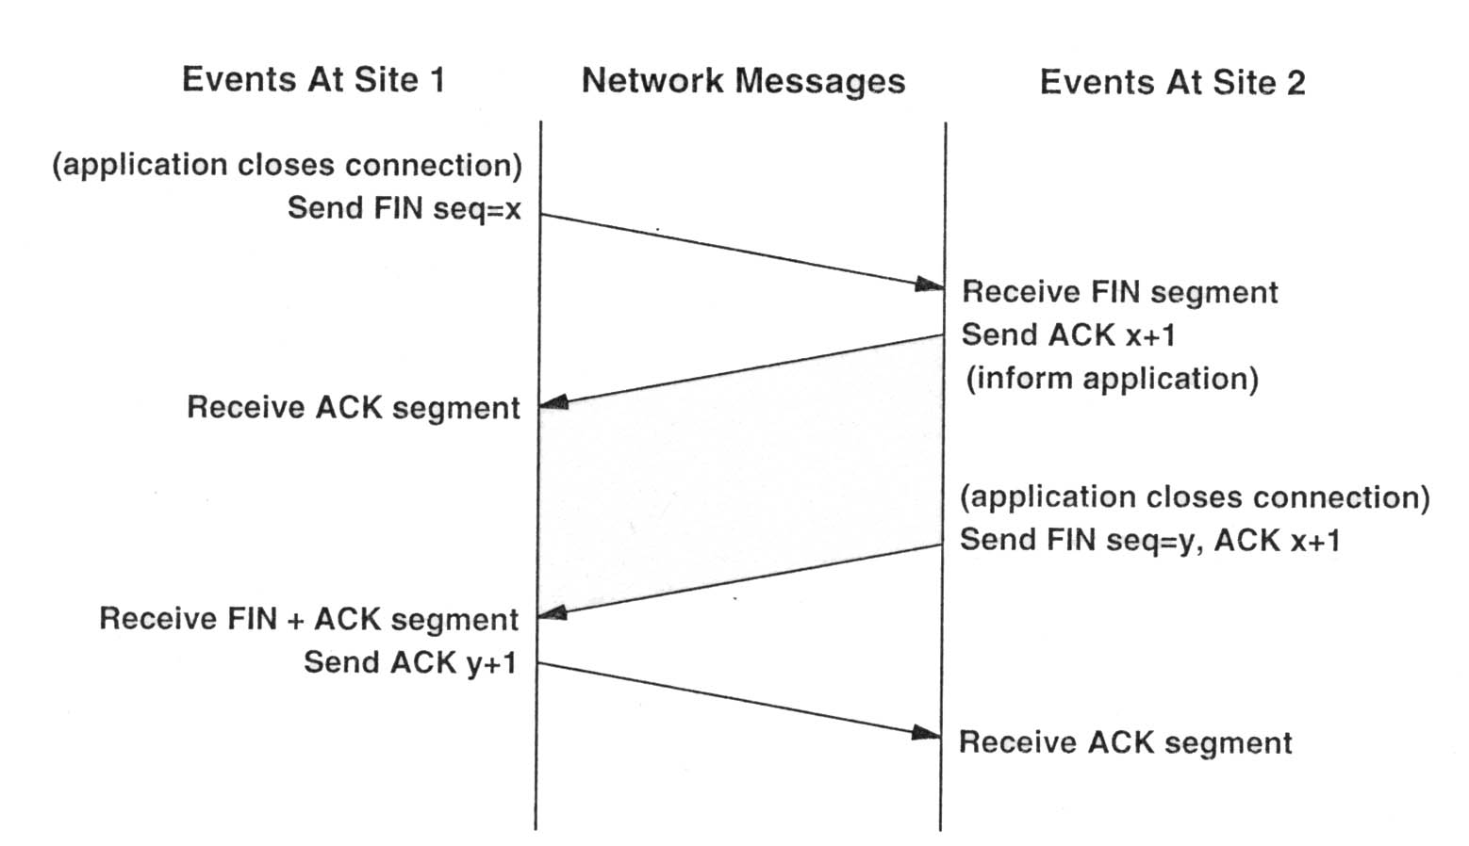

Figure Q. 3

Question 4. (22 marks)

A TCP opens a connection and uses slow start. Assume that the maximum window size is 50 and the window threshold is 16.
i) Approximately how many round-trip times are required before TCP can send 16 and 32 segments, (i.e. window size = 16 and 32), respectively? [14 marks]
ii) What does TCP respond for congestion control if a segment is lost at the round-trip times equal to 24? [8 marks]

i) TCP initializes the congestion window to 1, sends an initial segment, and waits. When the ACK arrives, it increases the congestion window to 2, sends 2 segments, and waits. When the 2 ACKs arrive, they each increase the congestion window by one, so that it can send 4 segments. It takes log216 = 4 round trips before TCP can send 16 segments.

After the congestion window size reach 16, TCP enter congestion avoidance mode. TCP will increase its window size by one when all Acks for a full congestion window of packets are received. It takes 32−16=16 more round trips to reach window size equal to 32. Adding the number of round trips needed in slow start mode, it takes totally 4+16=20 round-trips before TCP can send 32 segments.

(ii) At round trip times equal to 24, TCP’s window size has reached 36. When a segment is lost, the window threshold will be set to half of the current window size, i.e 36/2=18. If the lost is caused by time out, then the congestion window size will be set to one and TCP will enter the slow start mode. If the lost is caused by triple duplicate ACKs, then the congestion window size will be set to 18 and TCP will enter the congestion avoidance mode.

Question 5. (8 marks)

In this problem we consider the delay introduced by the TCP slow-start phase. Consider a client and a Web server directly connected by one link of rate R. Suppose the client wants to retrieve an object whose size is exactly equal to 13S, where S is the maximum segment size (MSS). Denote the round-trip time between client and server as RTT (assume to be constant). Ignoring protocol headers, determine the time to retrieve the object (including TCP connection establishment) when
i) 3 S/R > RTT > S/R, [4 marks]
ii) 5 S/R > RTT > 3 S/R. [4 marks]

i) The total delay is

2RTT + S/R + RTT + S/R + RTT + 4S/R + 6S/R = 4RTT + 12 S/R

ii) The total delay is

2RTT + S/R + RTT + S/R + RTT + S/R + RTT + 6S/R = 5RTT + 9 S/R

